AI-DRIVEN DETECTION OF HIP AND PELVIC FRACTURES IN
X-RAY IMAGING
Introduction

Neck of the femur, intertrochanteric fracture, and pelvic ring fractures are considered to be clinically serious forms of hip and pelvic fractures as they are accompanied by extreme dysfunction, diminished mobility, and by such complications as non-union and avascular necrosis. The proper treatment and better outcome of a patient are highly dependent on the accuracy and speed of diagnosis. Traditional radiographic diagnosis depends on expertise in radiologists, which may take some time and is also likely to be variable. The emergence of artificial intelligence (AI), specifically deep learning, promises to provide a groundbreaking solution to automate fracture detection and classification that can increase the accuracy of diagnosis and simplify clinical workflow. The proposed pilot study is designed to develop and test deep learning models (based on transfer learning) to automate the process of hip and pelvic fracture detection and classification in X-ray images. It is hypothesized that advanced models, i.e., already trained deep learning, could reach very high accuracy in the classification of complex fracture patterns, thus serving high-speed and accurate clinical decision-making.

Methodology
The data contained about 1000 x-ray pictures taken in Sri Lankan hospitals in 2022-2023. These images were hand-marked by expert radiologists based on five labels: non-fractures, non-displaced incomplete fractures, non-displaced complete fractures, completely displaced complete fractures, and incompletely displaced complete fractures. In order to strengthen the robustness of the dataset, preprocessing techniques like normalization and resizing were implemented, as well as data augmentation methods like rotation and flipping, and scaling in order to diversify the dataset and prevent overfitting. The data set was divided into training (70%), validation (15%), and testing (15%) sets. Deep learning models were pre-trained: CNN, InceptionV3, Resnet50, Resnet101, Mobilenet, Efficientnetb0, Efficientnetv2, and Xception. It used transfer learning by fine-tuning these models with the use of ImageNet weights. A categorical cross-entropy loss was used to train the models, and the Adam optimizer was used. Efficacy of the models was measured using performance metrics such as accuracy, precision, recall, and F1-score that were determined on the test set.

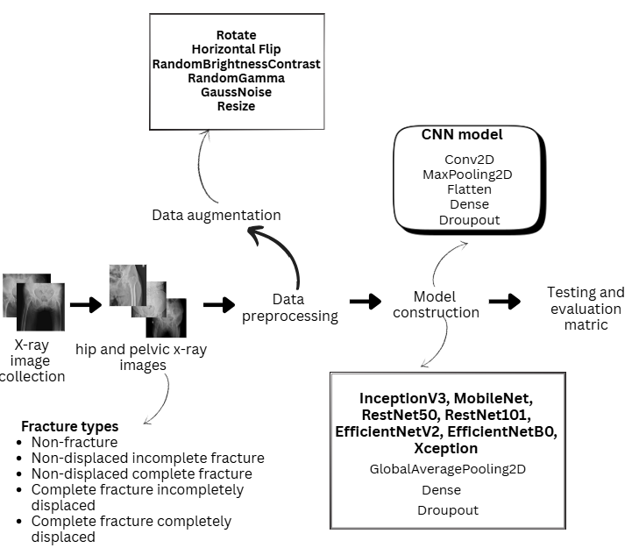
Figure 1: High level architecture
RESULTS AND DISCUSSION
The best-performing model was the ResNet101 model with an accuracy of 0.8000 on testing and a precision of 0.8179, followed by ResNet50 (accuracy: 0.7786, precision: 0.7298) and EfficientNetV2 (accuracy: 0.7500, precision: 0.6678). These findings suggest that such an architecture as ResNet101 proves to be successfully used to extract complicated morphologies of the fractures in x-rays, probably due to the residual learning paradigm that helps to overcome the problem of the vanishing gradient. The accuracy of ResNet101 is quite high, indicating that it is a model that can be considered when reducing the number of false positives is the main consideration of clinical practice to prevent any intervention that may not be necessary. Nevertheless, models such as EfficientNetV2, in spite of high computational efficiency, were slightly less efficient (maybe due to the rather lightweight nature of their models, which is less tailored to the complex nature of fracture patterns). Transferred learning efficiently saved training time and did not decrease the accuracy, which showed its effectiveness within the medical imaging application with low amounts of data. Among the difficulties, there were the imbalance of classes in the dataset, partly solved with the help of augmentation, and the possibility of overfitting in small models such as MobileNet. The findings highlight the possibility of AI-based solutions to optimize the diagnostic processes, especially in under-resourced environments such as Sri Lankan hospitals, where speed and precision of diagnosis are serious concerns.

Table 1: Performance evaluation of deep learning models
Model | Training accuracy | Validation accuracy | Testing accuracy | Training time (s) | Precision | Recall | F1
CNN | 0.8333 | 0.6763 | 0.6643 | 762.40 | 0.5530 | 0.6643 | 0.5833
InceptionV3 | 0.7129 | 0.6763 | 0.6857 | 795.97 | 0.5553 | 0.6857 | 0.5906
RestNet50 | 0.8919 | 0.7194 | 0.7786 | 1237.22 | 0.7298 | 0.7785 | 0.7364
RestNet101 | 0.8735 | 0.7338 | 0.8000 | 1817.57 | 0.8179 | 0.8000 | 0.7690
MobileNet | 0.7577 | 0.6904 | 0.7071 | 251.44 | 0.3134 | 0.7071 | 0.6129
EfficientNetB0 | 0.8750 | 0.7482 | 0.7286 | 404.34 | 0.6613 | 0.7286 | 0.6769
EfficientNetV2 | 0.8858 | 0.7338 | 0.7500 | 1330.01 | 0.6678 | 0.7500 | 0.6912
Xception | 0.7346 | 0.6906 | 0.6714 | 1339.33 | 0.4838 | 0.6714 | 0.5623

CONCLUSIONS
This research managed to design and test deep learning models in the automatic detection and classification of hip and pelvic fractures in X-ray images, where ResNet101 has the highest testing accuracy of 0.8000 and precision of 0.8179. The results reflect the effectiveness of the deep learning model on the basis of transfer learning, and especially the ResNet101, to precisely identify complicated fracture patterns, which is of considerable interest to clinical practice. Fracture automation can support accurate diagnosis, and workload of radiologists, and favorable patient outcomes in orthopedic practice in resource-scarce areas. The potential directions of future research would be introducing multi-modality imaging (e.g., CT or MRI), applying generative adversarial networks (GANs) to develop better data augmentation, and experimenting with ensemble methods to achieve an even greater model performance. These developments may lead to sounder use of AI in medical imaging assessment instruments.

References
- Sharrab, Y.O., Alsmira, M., Dwekat, Z., Alsmadi, I., and Al-Khasawneh, A.: ‘Performance comparison of several deep learning-based object detection algorithms utilizing thermal images’, in Editor (Ed.)^(Eds.): ‘Book Performance comparison of several deep learning-based object detection algorithms utilizing thermal images’ (IEEE, 2021, edn.), pp. 16-22
- fractures’, Journal of medical imaging and radiation oncology, 2019, 63, (1), pp. 27-32
- Bae, J., Yu, S., Oh, J., Kim, T.H., Chung, J.H., Byun, H., Yoon, M.S., Ahn, C., and Lee, D.K.: ‘External validation of deep learning algorithm for detecting and visualizing femoral neck fracture including displaced and non-displaced fracture on plain X-ray’, Journal of digital imaging, 2021, 34, (5), pp. 1099-1109
- Hashmi, H., Dwivedi, R.K., and Kumar, A.: ‘Comparative Analysis of CNN-Based Smart Pre-Trained Models for Object Detection on Dota’, Journal of Automation, Mobile Robotics and Intelligent Systems, 2024, pp. 31-45
- Kitamura, G.: ‘Deep learning evaluation of pelvic radiographs for position, hardware presence, and fracture detection’, European journal of radiology, 2020, 130, pp. 109139
- Kuo, C.-W., and Kira, Z.: ‘Beyond a pre-trained object detector: Cross-modal textual and visual context for image captioning’, in Editor (Ed.)^(Eds.): ‘Book Beyond a pre-trained object detector: Cross-modal textual and visual context for image captioning’ (2022, edn.), pp. 17969-17979
- Sanchez, S., Romero, H., and Morales, A.: ‘A review: Comparison of performance metrics of pretrained models for object detection using the TensorFlow framework’, in Editor (Ed.)^(Eds.): ‘Book A review: Comparison of performance metrics of pretrained models for object detection using the TensorFlow framework’ (IOP Publishing, 2020, edn.), pp. 012024
- Babu, B., and Khan, R.H.M.: ‘OBJECT DETECTION–A Comparison Between Pre-trained and Custom Model’, 2023
- Yadav, D.P., Sharma, A., Athithan, S., Bhola, A., Sharma, B., and Dhaou, I.B.: ‘Hybrid SFNet model for bone fracture detection and classification using ML/DL’, Sensors, 2022, 22, (15), pp. 5823
- Cheng, C.-T., Wang, Y., Chen, H.-W., Hsiao, P.-M., Yeh, C.-N., Hsieh, C.-H., Miao, S., Xiao, J., Liao, C.-H., and Lu, L.: ‘A scalable physician-level deep learning algorithm detects universal trauma on pelvic radiographs’, Nature communications, 2021, 12, (1), pp. 1066.

